Multiple choice section

|  |  |  |  |  |  |  |  |  |  |  |
| --- | --- | --- | --- | --- | --- | --- | --- | --- | --- | --- |
| Question | 1 | 2 | 3 | 4 | 5 | 6 | 7 | 8 | 9 | 10 |
| Answer | D | B | C | D | A | A | D | B | D | D |

Question 1 [8.2]

D

180° is a straight angle.

Question 2 [8.2]

B

10° is an obtuse angle.

Question 3 [8.2]

C

Complementary angles add to 90°.

Question 4 [8.6]

D

All three sides and all 3 angles are equal for an equilateral triangle.

Question 5 [8.3]

A

Vertically opposite angles are equal.

Question 6 [8.5]

A

The shape is a concave quadrilateral.

Question 7 [8.4]

D

Angles a and b are corresponding.

Question 8 [8.6]

B

The triangle is isosceles.

Question 9 [8.5]

D

This polygon has 8 sides so is an octagon.

Question 10 [8.4]

D

Angle y and 110° are corresponding angles.

Multiple-choice total marks: 10

Short answer section

Question 11 1 marks [8.1]

60°

Question 12 2 marks [8.1]

(a) 55° (b) 140° (c) ∠RAE

Question 13 4 marks [8.1]

(a)

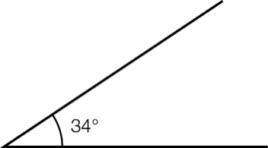

(b)   
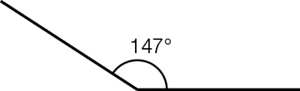

Question 14 3 marks [8.2]

(a) straight angle

(b) acute angle

(c) revolution

Question 15 3 marks [8.2]

(a) right angle

(b) obtuse angle

(c) reflex angle

Question 16 3 marks [8.2]

(a) Supplementary angles add to 180°.  
155 + 25 = 180

(b) Complementary angles add to 90°.  
30 + 60 = 90

(c) Neither angles add to 200°  
120 + 80 = 200

Question 17 3 marks [8.3]

x + 39 + 123 = 180 (supplementary angles add to 180°)

x = 180° – 162°

x = 18°

Question 18 3 marks [8.3]

x + 131 + 142 + 49 = 360 (angles in a revolution)

x + 322 = 360

x = 38°

Question 19 1 marks [8.4]

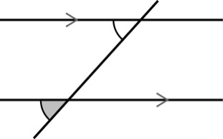

(corresponding angle marked in grey)

Question 20 2 marks [8.4]

x + 57 = 180

x = 123°

(co-interior angles on parallel lines)

Question 21 4 marks [8.5]

Triangles, square, hexagon and dodecagon

Question 22 4 marks [8.6]

|  |  |
| --- | --- |
| (a) x + 58 + 97 = 180 (angle sum in a triangle) x + 155 = 180 x = 25° | (b) x + x + 44 = 180 (angles in an isosceles triangle) 2x + 44 = 180 (angle sum of a triangle) 2x = 136 x = 68° |

Question 23 2 marks [8.6]

x = 118 + 38

(exterior angle of a triangle)

x = 156°

Question 24 3 marks [8.8]

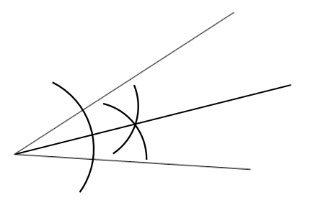

Question 25 3 marks [8.5]

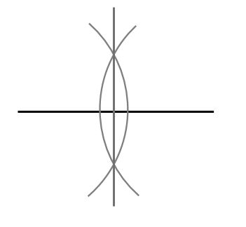

Short answer total: 41

Extended answer section

Question 26 5 marks [8.7]

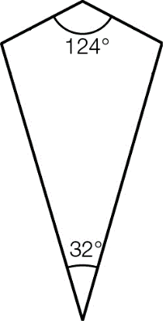

x + x + 124 + 32 = 360

2x + 156 = 360

(angle sum of a quadrilateral)

(opposite angles in a kite are equal)

2x = 204

x = 102°

Question 27 6 marks [8.7]

30 + 3x = 90

(complementary angles add to 90°)

3x = 60

x = 20°

Question 28 5 marks [8.7]

(a) x + 45 + 105 + 155 = 360

(b) x + 305 = 360  
x = 55°

Extended answer total: 16

TOTAL test marks: 67